

**IOT based Smart Parking System**

**Submitted To**

Engr. Awais Islam

Lecturer IED

University of Engineering and Technology, Taxila

**Submitted By**

Muhammad Qadeer 18-IE-03

Haris Dilawar 18-IE-27



# ABSTRACT

In recent times the concept of smart cities has gained grate popularity. Thanks to the evolution of Internet of things the idea of smart city now seems to be achievable. Consistent efforts are being made in the field of IoT to maximize the productivity and reliability of urban infrastructure. Problems such as, traffic congestion, limited car parking facilities and road safety are being addressed by IoT. In Pakistan we are still using the manual vehicle parking system because of which we are facing problems like wastage of time and fuel finding free space around the parking ground when we need to park our car which requires a good amount of lighting. Another issue is chaos that happens while parking because there is no system anyone can park anywhere that sometime causes damage to the vehicles while moving out or in the parking lot. Security is also an issue there. In this project, we used IoT to build such a smart parking system that will help us overcome these obstacles and reduce the wastage of time, fuel and ensure safety and security. The components of our model are programmed using Arduino such that when the number of slots is filled, it will not let the barrier to lift. While in case of availability of empty slots, the barrier will automatically lift using a servo motor. Also, an LCD screen is installed that will show the number of slots available and the total number of slots. If the parking area is filled, the drivers will see from quite a long distance and will thus move their vehicles to find an alternate parking place thus saving their time and fuel.

Contents

ABSTRACT 2

List of Figures 5

Chapter 1:  Introduction: 6

1.1 Introduction to Smart Car Parking System 6

1.2. Problems with the Traditional car parking system 7

1.3. Advantages of Smart Parking System 7

1.4 Motivation and Objectives 8

1.4.1 Motivation 8

1.4.2 Objectives 8

1.5 Different Types of Smart Car parking Systems 8

1.6 Summarization of our project 8

Chapter 2: Overview of project 9

2.1 Applicability of our project 9

**2.2 Working principle of our project** 10

Chapter 3:  Hardware and Software Components 11

3.1 Introduction 11

3.2 Hardware Components 11

3.2.1Arduino Uno R3 12

3.2.2 RC Micro Servo (Hitec HS-55 or similar) 13

3.2.3 LCD Display 13

3.2.4 10k resistor (3 Pin) 14

3.2.5 Mini Breadboard 170 points 14

3.2.6 Cable Jumpers Male-to-Male 14

3.2.7 Solid Wire AWG #22 15

3.2.8 Cardboard 16

3.2.9 IR sensor 16

3.3 Software Components 17

3.3.1 Arduino 1.8.3 17

3.3.2 Proteus Software 17

Chapter 4: Physical Prototype and Algorithm 18

4.1 Procedure for making physical model 18

4.2 Simulation 21

4.2.1 Proteus Design 21

4.2.2 Simulation of Smart Parking System using Proteus 8 21

4.3 Algorithm 22

4.3.1 Display Arduino code 22

Chapter 5: 24Economic Overview 24

5.1 Economical Benefits of Automated Car Parking System 24

5.1.1 More Profitable Land Use 24

5.1.2 Parking Optimized for Profitability 24

5.1.3 Capital Cost 24

5.1.4 Reduced Fuel &Maintaining Costs 24

5.1.5 Inherent Securities 24

5.1.6 Lower Risk & Liability 24

5.1.7 Tax Advantages 25

5.2 Losses due to manual car parking 25

5.2.1 Improper usage of lands 25

5.2.2 Added capital cost 25

5.2.3 Extra fuel and maintenance cost 25

5.2.4 Risk and liability 25

5.2.5 Wastage of time 25

5.2.6 Other disadvantages 25

Chapter 6: Planning and Budget 26

6.1 Planning for prototype project 26

6.1.1 Timeline for Prototype 26

1.6.2Budget for the model 27

Chapter 7: Conclusion 28

7.2 Future Ideas/Improvements 28

7.2.1 Smart recognition of cars 28

7.2.2 Updating Users about available slots and account balance 28

References 29

# List of Figures

1.1.0: Existing Car Parking……………………………………………………………………………7

3.2.1: Arduino R3 Board………………………………………………………………………………12.

3.2.2: RC Micro Servo…………………………………………………………………………………13

3.2.1: LCD………………………………………………………………………………………………13

3.2.5: Breadboard……………………………………………………………………………………...14

3.2.6: Cable jumpers…………………………………………………………………………………..14

3.2.7: Solid Wire AWG………………………………………………………………………………...15

3.2.8: Cardboard……………………………………………………………………………………….16

3.2.9: IR sensor………………………………………………………………………………………...16

3.3.1: Arduino software ………………………………………………………………………………..17

3.3.2: Proteus……………………………………………………………………………………………17

4.1: Physical Model……………………………………………………………………………………..18

4.21: Simulation…………………………………………………………………………………………21

# Chapter 1

# Introduction:

## 1.1 Introduction to Smart Car Parking System

Over the decades our country has been developed drastically, now we are in this state that we have a lot of well contacted roads, commercial building and increasing number of automobiles. While parking these automobiles in parking space we use the manual procedure of parking. Which most of the cases is unplanned and lack of discipline due to this, people can park their cars anywhere they want to, which creates a mess as people do not follow the cue most of the time. As a result of this, a huge traffic jam takes place in that place. While parking in and retrieving car due mismanagement cars can get dent by bumping with each other as there is lack of sufficient space. This leads to arguments, fights among people which sometimes makes huge traffic jam. This is also an economical loss as we need to repair our damaged car and cars consume extra fuel while parking in or out. Traffic jam is an issue here as it kills our precious time. Due to this chaos in parking our valuable time gets wasted. It harms the students, office going staffs and emergency patients to a great extent.

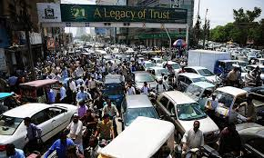

Figure 1.1 Existing Car Parking

It also causes economical loss to commercial places like shopping malls, amusement parks as people are more likely not to visit these places due to this parking hazard. As we are advancing with time, the manual car parking system in commercial spaces is creating hurdle which is causing wastage of time and some economic losses as well. Therefore, we need a solution which can overcome these problems. Here we are introducing Smart Parking System as a solution of these problems as well as car parking system in commercial spaces is creating hurdle which is causing wastage of time and some economical losses as well. Therefore, we need a solution which can overcome these problems. We are introducing Smart Car Parking System as a solution of these problems as well as a replacement to the manual car parking systems at commercial spaces. This system not only saves time and money, but it can also earn money by charging for parking spaces.

## 1.2. Problems with the Traditional car parking system

Traditional or manual car parking system is everywhere in our country, but this system is full of problems. Some are following.

1. We can see in many shopping malls, hospitals huge traffic jam in front of the parking. The parking guard stops the entire vehicle and gives a payment slip, this creates traffic jam.
2. It is difficult and time consuming to find out the parking slot which costs extra fuel and wastes time.
3. Security problem is one another problem in manual car parking, people can enter in parking slot and there snatching, robbery can happen.

## 1.3. Advantages of Smart Parking System

The advantages of smart car parking systems are:

1. **Reducing traffic jam**

Smart vehicle system reduces the traffic jams because the LCD clearly shows the situation of parking area and if the area is completely filled, the new entrants can take turn and find alternate place instead of waiting in lines.

1. **Time saving**

It is a time saving system. In manual parking system it is too hard to find out the empty space for parking, it is very much time consuming. Sometimes it causes late in meeting or other important works.

1. **Safety in the parking**

Here no people can enter in the parking so that there is no chance of snatching, robbery, stealing, sometimes in silent parking space peoples are being harassed. This system prevents these problems.

1. **Fuel saving**

In this system we are using well organized slots for vehicles which will be sensed by ultrasonic sensors. This will reduce the fuel cost. Here we do not need to light all over the parking space. It will on the light when it moves and where is the path and it is very much electricity saving also.

1. **Operating cost saving**

Over a period, the parking charge collecting cost is reduced. There is reduction in the man-hour required as the system does not require any human interaction for the money transaction.

## 1.4 Motivation and Objectives

### 1.4.1 Motivation

The motivation of the project is, we want to digitalize our daily life as well as our country. In many countries this automated vehicle system is available and popular.

### 1.4.2 Objectives

The objectives are following

1. Project's main purpose is to produce a real-life solution to the car parking problem which the whole world is facing frequently.
2. Design and build up a prototype of smart car park system.
3. Learn how to control the prototype system for smart parking.
4. Acknowledge how to program Arduino and make it work on any system.
5. Compare various aspects of this manual parking system with the au parking system.
6. Find out the economic benefits of introducing smart vehicle system.

## Different Types of Smart Car parking Systems

Here are some widely use types of smart car parking system:

* AGV systems
* Crane systems
* Puzzle systems
* RGC systems
* Silo Systems

## 1.6 Summarization of our project

Here we are trying to build a suitable computerized Smart Car Parking System. An assessment of the existing system would be made including the operating system being made as a prototype, the efficiency of car parking system, problem faced during operating the prototype etc. An in-depth analysis of the Smart Car Parking System would then be made. Various aspects of these two systems would then be compared and the benefit of introducing the SMART CAR PARKING System would be found out in terms of saving in time, fuel, and emission reduction.

# Chapter 2

# Overview of project

## 2.1 Applicability of our project

Over the decades with the development of our country we have reached in a situation where the manual car parking system in commercial spaces needs to be replaced. The manual car parking system is causing hurdle and chaos in parking space, therefore resulting in wastage of time and some economic losses as well. Therefore, introducing Smart Car Parking Systems in commercial spaces can be replacement to the manual car parking systems at commercial spaces. We can install this system in the places like**,**

* **Office buildings**

It will help the staff to park their car without any hurdle and wastage of time. It will also relieve their mind from the unnecessary parking hurdle. Also, if someone is already late, he would not be late any further by having to search for the parking space and park his car. It will also provide security to their cars from stealing.

* **Shopping Malls**

It will help the customers to park their car without any hurdle, which will give them time to browse for more products. It will benefit both the customers and the sellers as the customer will have more time to explore their options and the sellers have more product options to sell. It will increase the number of customers coming in the malls. It will increase revenue as the customer has to pay for the parking space. It will also help removing the cars which are kept all day long without shopping purposes as they need to pay for parking their cars. As there is a time limit for the parking space the customers will keep that in mind, and they will remove their cars on time. This will help more customers to come to these malls each day. It will also provide security to their cars from stealing.

* **Hospitals**

In hospital when there are a lot of emergency cases there are a lot of a cars and ambulances coming in the parking space. This creates jam which cause delay for the patients to receive the medical services, which often can be fatal to them. If we install the automated system, it will take less time to park car and the patients to reach the medical services. Also, they can earn revenue for cars other than the ambulances. It will also provide security to their cars from stealing.

* **Amusement Parks**

If we install automated car parking systems in amusement parks it will attract more people to come to these places. The more the people will come the more revenue will be earned. Moreover, these amusement parks relieve us from our dull and monotonous lives, refreshes our mind. The more people can enjoy these places due to the advanced parking facility. It again increases the revenue as people need to pay for parking their cars. It will also provide security to their cars from stealing.

Along with these places we can use this system in educational institutes and mosques where car parking area is available. It will help people to park their car easily without making any hurdle. It will also provide security to their cars from stealing.

## 2.2 Working principle of our project

Our project will work as follows:

The LCD screen displays the total number of slots in the parking area, and the number of slots available. LCD, IR sensors, and servo motor are programmed through Arduino. When the vehicle comes close to the barrier, the IR sensors detect them and if there is a slot available, the program commands the servo motor to move the barrier by 90 degrees. And if there is no slot available, the barrier will not move, and the LCD screen shows that there is no slot available. The range of IR sensors are adjusted, and the servo motor is programmed to rotate the barrier by 90 degrees angle. So, these major components, programmed by Arduino, will make this system functional. Dry cell batteries or direct charger of 5 volts can be used as an input voltage source.

# Chapter 3

# Hardware and Software Components

## 3.1 Introduction

To have a proper knowledge about the hardware components as well as the software components of the project is a must. Arduino Uno played a vital part in our project as it contains all the software data in it.

## 3.2 Hardware Components

We have used the following hardware components for our project

* Arduino UNO R3
* Servo motor
* Arduino wires
* IR sensors
* LCD screen
* Mini breadboard 170 points
* Jumper wires (Male to Male)
* 5V charger
* 3.5V cell
* Cell carrier
* Connectors
* Pencil (for barrier)
* 6 toy cars
* Cardboard

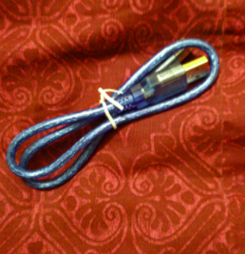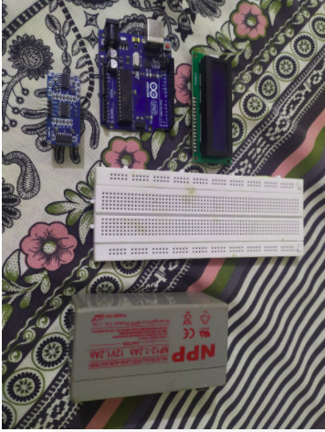

### 3.2.1Arduino Uno R3

The Arduino Uno R3 is a microcontroller board based on a removable, dual-inline-package (DIP) ATmega328 AVR microcontroller. It has 20 digital input/output pins (of which 6 can be used as PWM outputs and 6 can be used as analog inputs). Programs can be loaded on to it from the easy-to-use Arduino computer program. The Arduino has an extensive support community, which makes it a very easy way to get started working with embedded electronics. The R3 is the third, and latest, revision of the Arduino Uno.

As stated above programs can be loaded on it to use is efficiently, so we make a program on Arduino for smart parking system.

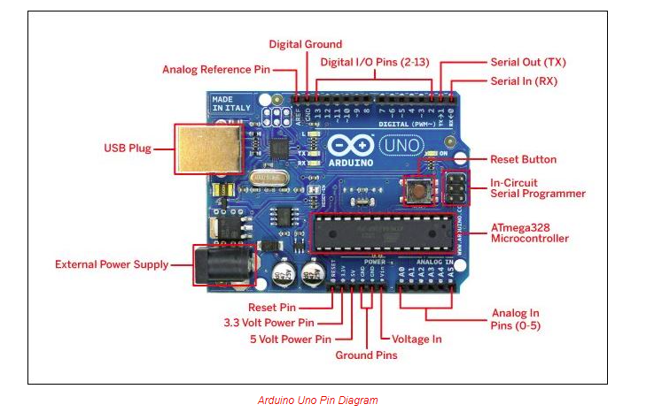

Figure 3.2.1: Arduino R3 Board

### 3.2.2 RC Micro Servo (Hitec HS-55 or similar)

Servos (also RC servos) are small, cheap, mass-produced servomotors or other actuators used for radio control and small-scale robotics. Most servos are rotary actuators although other types are available. Linear actuators are sometimes used, although it is more common to use a rotary actuator with a bell crank and pushrod. Some types, originally used as sail winches for model yachting, can rotate continuously.

We used RC Micro Servo to open and close the barrio to our smart parking area. It is operated with Arduino; Arduino operate it by detecting available space in the parking area.

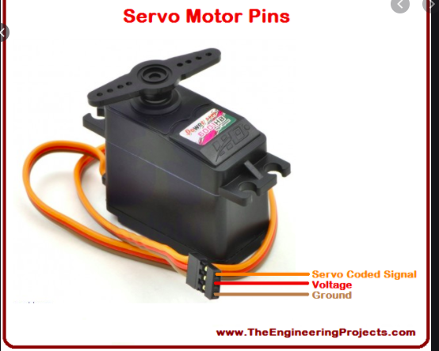

Figure 3.2.2 RC Micro Servo

### 3.2.3 LCD Display

Liquid -crystal display known as LCD is a flat-panel display or electronically modulated optical device that uses the light modulating properties of liquid crystals, liquid crystals do not emit light directly, instead using a backlight or reflector to produce images in color or monochrome. LCDs are available to display arbitrary or fixed images with low information content, which can be displayed or hidden, such as preset words, digits, and 7-segment displays, as in a digital clock. They use the same basic technology, except that arbitrary images and made up of many small pixels. LCDs are used in wide range of applications such as: computer monitors, televisions. Instruments panels, aircraft cockpit displays indoor and outdoor signage, digital cameras, and mobile telephones, including smart phones.

We used this display to show.

* Total space in parking area.
* Available space in parking area.

It is also programed with Arduino. Arduino detect space in the parking area them show it on this LCD display.

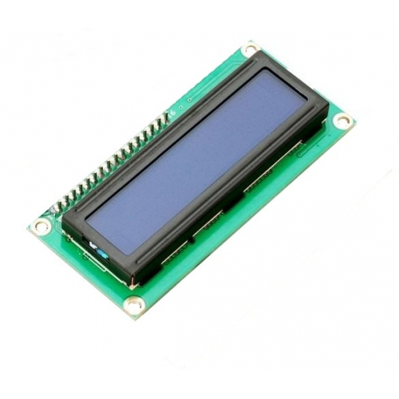  
Figure 3.2.1 LCD

### 3.2.4 10k resistor (3 Pin)

A resistor is a passive two-terminal electrical component that implements electrical resistance as a circuit element. In electronic circuits, resistors are used to reduce current flow, adjust signal levels, to divide voltages, bias active elements, and terminate transmission lines, among other uses.

### 3.2.5 Mini Breadboard 170 points

A breadboard is a construction base for prototyping of electronics. Originally the word referred to a literal bread board, a polished piece of wood used for slicing bread. In the 1970s the solderless breadboard (a.k.a. plugboard, a terminal array board) became available and nowadays the term "breadboard" is commonly used to refer to these. Because the solderless breadboard does not require soldering, it is reusable. This makes it easy to use for creating temporary prototypes and experimenting with circuit design. We used the breadboard to make our circuit.

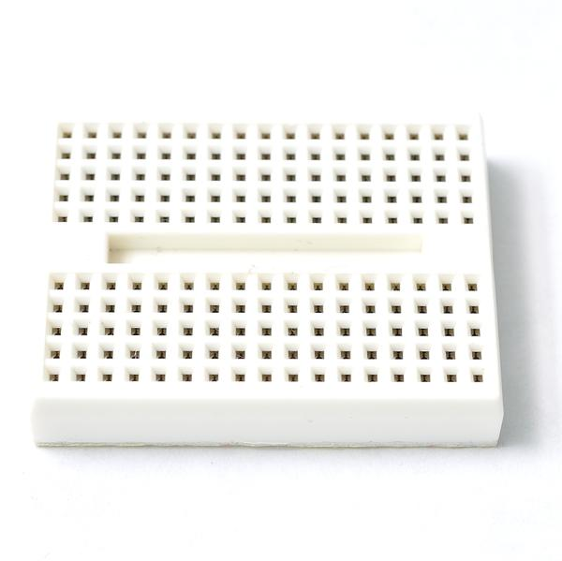

Figure 3.2.5: Breadboard

### 3.2.6 Cable Jumpers Male-to-Male

A jump wire (also known as jumper wire, or jumper) is an electrical wire, or group of them in a cable, with a connector or pin at each end (or sometimes without them – simply "tinned"), which is normally used to interconnect the components of a breadboard or other prototype or test circuit, internally or with other equipment or components, without soldering.

Jumper wires typically come in three versions: male-to-male, male-to-female, and female-to-female. The difference between each is in the end point of the wire. Male ends have a pin protruding and can plug into things, while female ends do not and are used to plug things into. Male-to-male jumper wires are the most common and what you likely will use most often. When connecting two ports on a breadboard, a male-to-male wire is what you will need.

So, we used male-to-male jumper wires to make connections on breadboard.

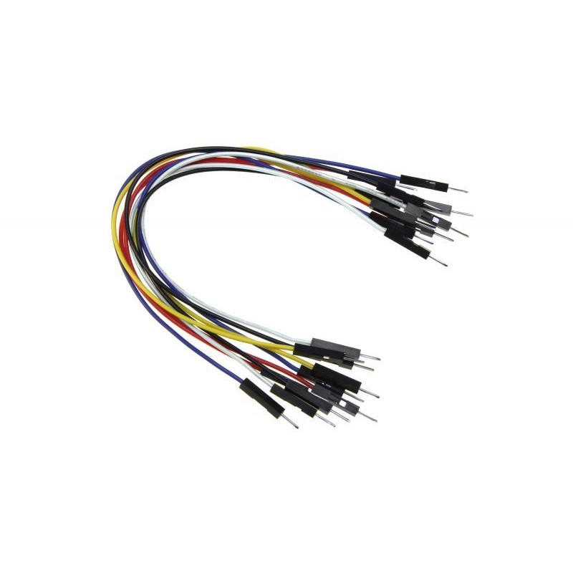

Figure 3.2.6: Cable jumpers

### 3.2.7 Solid Wire AWG #22

The common standard for the diameter (gauge) of round drawn wire is the American Wire Gauge (AWG). As strands of wire are made, they are drawn through progressively smaller dies. This is true of all wire. In fact, the AWG sizing system suggests this drawing procedure. For example, a size 22 AWG wire, smaller than 20 AWG, is drawn, theoretically, through 22 progressively smaller dies. Solid wire AWG #22 are like jumpers’ wires theses are to make connections in breadboard for circuits. We also used these wires to make connections.

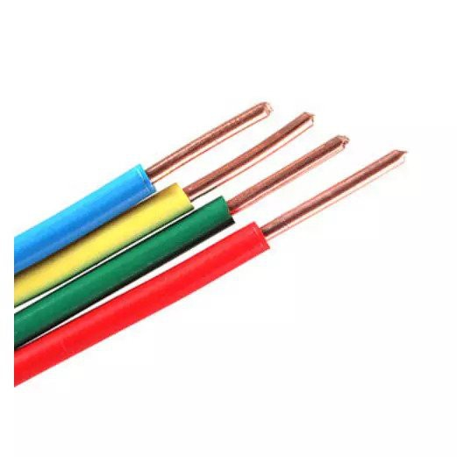

Figure 3.2.7: Solid Wire AWG

### 3.2.8 Cardboard

Cardboard is a generic term for heavy-duty paper-based products having greater thickness and superior durability or other specific mechanical attributes to paper, such as foldability, rigidity, and impact resistance. The construction can range from a thick sheet known as paperboard to corrugated fiberboard which is made of multiple corrugated and flat layers.

We used cardboard to make project on it (fixing different components of project on this board).



Figure 3.2.8: Cardboard

### 3.2.9 IR sensor

An IR sensor consist of a transmitter, receiver, power LED, obstacle LED, and distance adjustment knob. The IR receiver is a photodiode and pre-amplifier that converts the IR light into an electrical signal. One pin of IR sensor is connected with the Arduino that will program it, 2nd with the Vcc voltage source, while 3rd one is grounded.

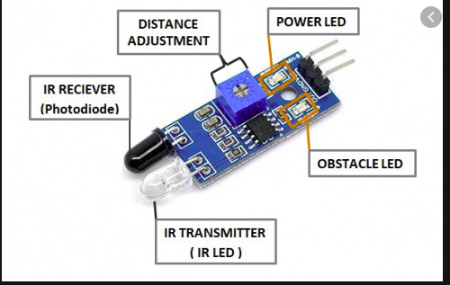

Figure 3.2.9: IR sensor

## 3.3 Software Components

### 3.3.1 Arduino 1.8.3

The Arduino IDE software is known that Arduino IDE is open-source software. This software is used to compile the program into the microcontroller. It uses C-programming language for coding. There is two parts in this code mainly, one is Void setup () which is known as preparation for the program and it runs only once and another one is void loop () which is known as execution for the program.



Figure 3.3.1: Arduino software

### 3.3.2 Proteus Software

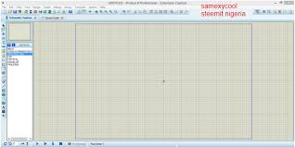The Proteus Design Suite is a proprietary software tool suite used primarily for electronic design automation. The software is used mainly by electronic design engineers and technicians to create schematics and electronic prints for manufacturing printed circuit boards.

Figure 3.3.2: Proteus

# Chapter 4

# Physical Prototype and Algorithm

## 4.1 Procedure for making physical model

**Step 1:**

Take a piece of cardboard and make a sketch of the points where each component is to be placed.

**Step 2:**

Place the bread board at its place and insert the pins of LCD in it and fix it.

Also place two sensors at the passage of vehicles entry point.

Either glue or sticky tape can be used to fix these components.

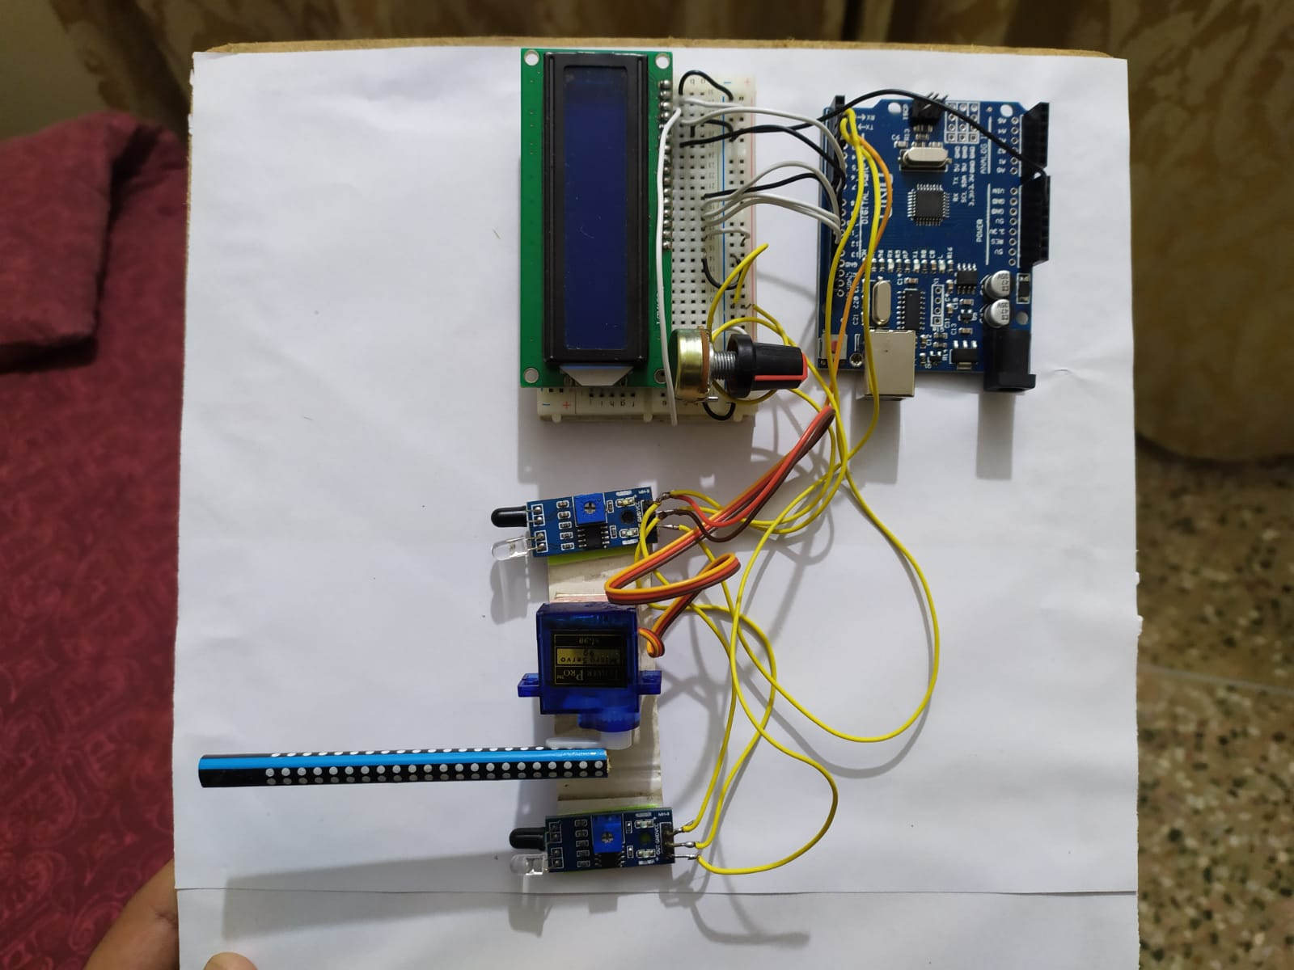

**Step 3:**

Now, place the servo motor between the IR sensors. The three wires of servo motor are also connected in the same way as in case of IR sensors.

Yellow wire: With digital pin 4 of Arduino

Brown wire: Grounded

Red wire: with negative point 10 on breadboard

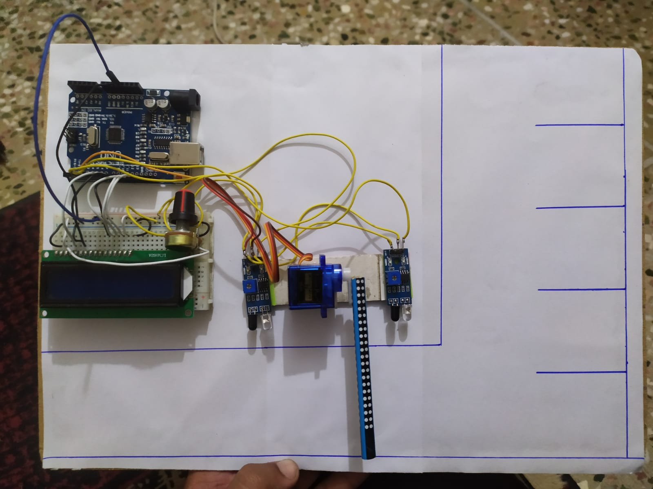

Figure 4.1: Physical Model

**Note:** The dry cells are later removed because they were discharged.

**Step 4:**

Connect the pins of the IR sensors with following:

Pin 1: With Vcc voltage source

Pin 2: Grounded

Pin 3: With digital pins 2 and 3 of Arduino uno

Procedure is same in case of both sensors.

**Step 5:**

Now, the digital pins 8 to 13 are connected with the LCD.

* 8 and 9 with RS and E pins of LCD.
* 10, 11, 12 and 13 with data pins 4,5,6 and 7 respectively

**Step 6:**

A 10K variable resistor (3 pin) is inserted in the breadboard to control the current flow in the circuit.

Pin 1: connected with VEE

Pin 2: connected from B to +ve terminal of breadboard using connecting wire

Pin 3: connected from A to –ve terminal of breadboard

**Step 7:**

The breadboard is also grounded using connecting wire.

**Step 8:**

Then, Arduino is connected with the Laptop in which the program/algorithm is made.

**Step 9:**

The servo motor is run using a separate 5V charger.

Dry cell as well as direct power supply using 5V charger is used. So, we can give it power supply through two different sources.

In case if light if OFF, the charged cells can be used to run the model.

**Step 10:**

In the end, the program is run in Arduino software. This runs the circuit.

Now, a car is brought near the barrier, the LCD shows 5 available spaces, so the program directs the servo motor to rotate through an angle of 90 degrees. In the same way, 4 more cars are brought near the barrier and it opens. But when the 6th car is brought near it, it will not rotate, and the LCD will show that all the slots are filled.

Similar phenomenon will happen when a car moves out of the parking area.

## 4.2 Simulation

### 4.2.1 Proteus Design

****The Proteus Design Suite is a proprietary software tool suite used primarily for electronic design automation. The software is used mainly by electronic design engineers and technicians to create schematics and electronic prints for manufacturing printed circuit boards.

### 4.2.2 Simulation of Smart Parking System using Proteus 8

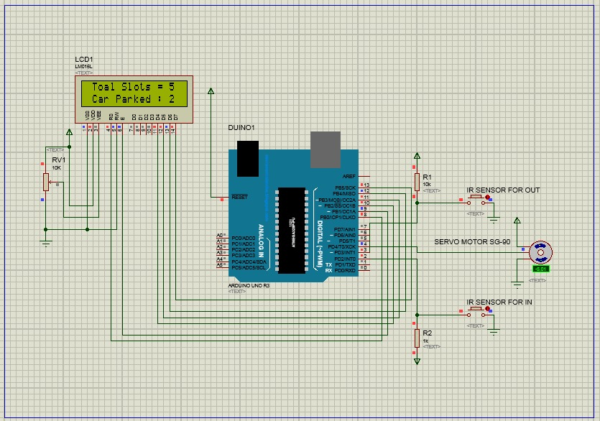Figure 4.21: Simulation

## 4.3 Algorithm

### 4.3.1 Display Arduino code

#include <Servo.h>

int pos = 0;

#include <LiquidCrystal.h>

Servo myservo;

LiquidCrystal lcd(8, 9, 10, 11, 12, 13);

int c=0;

void setup() {

myservo.attach(4);

lcd.begin(16, 2);

lcd.print(" Total Slots = 5 ");

pinMode(2,INPUT);

pinMode(3,INPUT);

myservo.write(90);

}

void loop() {

lcd.setCursor(0, 1);

lcd.print(" Car Parked : ");

lcd.print(c);

myservo.write(90);

if(digitalRead(2)==0){

if(c<5){c++;

myservo.write(0);

while((digitalRead(3)==1));delay(1000);

}

else{

lcd.setCursor(0, 1);

lcd.print(" Space is Full ");delay(2000);

}

}

if(digitalRead(3)==0){

if(c>0){ c--;}

myservo.write(0);

while((digitalRead(2)==1));delay(1000)

# Chapter 5

# Economic Overview

## 5.1 Economical Benefits of Automated Car Parking System

### 5.1.1 More Profitable Land Use

SPS (Smart parking systems) require significantly less area and volume for a given number of parking spaces than other parking options. SPS enables the more profitable use of valuable land for tenants, green space etc. and provide property developers various options such as: minimizing the area needed for parking to maximizing the number of parking spaces or some optimum point in between the two.

### 5.1.2 Parking Optimized for Profitability

Conventional parking solutions are too large or unfeasible whereas the design flexibility of SPS allows them to fit in locations or areas. SPS can be installed inside, under or between existing structures, very narrow and deep areas, and even irregularly shaped spaces: horizontally, vertically, or both. SPS help increase profitability by using unusable or lower value space for car parking.

### 5.1.3 Capital Cost

The common idea that the SPS always cost more than multi-story parking garages is overly simplistic and frequently incorrect. SPS can be replacements for conventional car parks SPS’s substantially smaller size and design flexibility can significantly shift capital cost and project profitability for if the developers incorporate them into preliminary designs.

### 5.1.4 Reduced Fuel &Maintaining Costs

Operation and maintenance costs are highly specific to each application. SPS have the advantage of requiring no or minimal lighting, ventilation, fire suppression, monitoring, clean up, staff and security measures in the unoccupied parking area unlike the conventional car park.

### 5.1.5 Inherent Securities

The SPS concept inherently provides much higher levels of protection and security for cars, their contents, and their drivers. Vandalism and theft are virtually impossible in an SPS. Personal security is much higher than in car parks since drivers and passengers are always in well-lighted, highly visible/public entry and exit areas at street level. SPS is also an ideal solution for the handicapped since entry and exit bays can readily accommodate specific requirements and building codes.

### 5.1.6 Lower Risk & Liability

Insurance premiums are often heavily influenced by the probability of accidents or other events occurring, here SPS may help as SPS minimize the potential for property damage, theft, personal injury, or death. The possibility of dents, scratches, other damage and vandalism to cars, theft of property from cars, car theft, robbery, arson, fire, assault, rape, falls and suicide can be reduced greatly by using the inherent safety and security of SPS.

### 5.1.7 Tax Advantages

The property developers may have significant tax advantages in the form of accelerated depreciation compared to car parks or parking garages by using SPS. Several countries permit faster, or accelerated, depreciation rates for equipment based on its useful life as equipment value declines at a faster rate in the earlier years. SPS may be eligible for much higher depreciation rates increasing profitability compared to the 25-to-50-year depreciation of buildings such as car parks.

## 5.2 Losses due to manual car parking

5.2.1 Improper usage of lands**:**

As the manual car parking systems are unplanned, they lack the proper usage of lands, which is unprofitable for property developers. It is unable to use unused property without proper shape which is again wastage of land.

5.2.2 Added capital cost**:**

Manual car parking system adds extra expenditure to capital cost as it is comparatively costlier than the smart car parking system.

5.2.3 Extra fuel and maintenance cost**:**

Manual car parking system there is huge maintenance cost. Also, there is added fuel expenditure while parking in or out the cars.

5.2.4 Risk and liability**:**

Insurance premium often heavily influenced by the probability of accidents or other events occurring, using manual car parking system may maximize the potential for property damage, theft, personal injury, or death. The possibility of dents, scratches, other damage and vandalism to cars, theft of property from cars, car theft, robbery, arson fire, assault, rape, falls and suicide can take place as safety and security of manual car parking systems are that much reliable.

5.2.5 Wastage of time**:**

As manual car parking systems are not planned properly it takes a lot of time for finding parking space, parking in, and retrieving the vehicles.

5.2.6 Other disadvantages**:**

There are a several other disadvantages of manual car parking systems. Such as:

* Manual car parking systems are not eco-friendly they cause noise, GHG emission and sometimes make the parking ground dirty due to disposal of litters by people.
* Manual car parking systems are not sustainable.
* Manual car parking systems sometimes block air and sunlight.
* Manual car parking systems can hardly to be recycled.

# Chapter 6

# Planning and Budget

## 6.1 Planning for prototype project

### 6.1.1 Timeline for Prototype

|  |  |  |
| --- | --- | --- |
| **Year 2020** | | |
| October | November | December |
| Hh 1) Topic Selection  2) Identifying the objective of the project  3) Theoretical study and basic understanding.  4) Gathering ideas for designing |  |  |
|  | 1) Budget planning  2) Searching and purchasing of material (market visits).  3) Working on Arduino  4) Writing codes |  |
|  |  | 1)Components gathering for prototype  2)finalizing Arduino code (Removing errors)  3) Finalizing simulation of circuit on Proteus 8.  4) Completing the full prototype  5) Simulating all codes and merging with hardware  6) Writing the report  7) Preparation of slides on PowerPoint |
|  |  |  |

### 1.6.2Budget for the model

|  |  |  |  |  |
| --- | --- | --- | --- | --- |
| **#** | **Component** | **Price (PKR)** | |  |
| 1 | Arduino Uno R3 | 690 | |
| 2 | Arduino wires | 80*2 | |
| 3 | IR sensors | 125*2 | |
| 4 | Servo motor | 240*2 | |
| 5 | LCD | 250 | |
| 6 | Wires | 50 | |
| 7 | B. B | 300 | |
| 8 | 5V charger | 180 | |
| 9 | 3.5 V cell | 200 | |
| 10 | 3.7V cell carrier | 150 | |
| 11 | Jumper Wires(M-M) | 125 | |
| 12 | Connectors | 50*2 | |
| 13 | 6 cars | 200 | |
| Total Cost | | Rs 3,135 | |
|  | | |

# Chapter 7

# Conclusion

In this project, we used Artificial Intelligence techniques to provide a smart and intelligent solution to a very basic problem which almost every common city of the country is facing. Interesting thing about this model is that it is not limited to a specific industry or a place, rather it can be implemented at almost every public place thus saving time, fuel and improving security and safety as well. If we list down the major benefits of this model, these are as follow:

* time and fuel saving
* can also provide sustainable parking management in an eco-friendly manner
* There is less maintenance cost for this system
* It provides security to the parking ground

Also, the maintenance cost is very low. Our model is multi powered means that power can be supplied using either of the two sources. In case when we have no accessibility to electricity, it can be run through charged dry cell batteries. Starting from the very basic level, we learnt the common terminologies, Arduino programming, went through circuit simulation software. Though ups and downs came but we did try to give our best to our project. But innovation has no barriers, furthermore improvements can be brought in this project either connecting it with mobile phone devices or through making smart cards.

## 7.2 Future Ideas/Improvements

### Smart recognition of cars

We can recognize the cars by their number plates with the help of image processing in SPS system. By using this type of technology, users can directly pay for their car parking using mobile phone’s prepaid balance or car parking account balance.

### Updating Users about available slots and account balance

User can get updates about available slots of a particular parking space and account balance by sending a simple SMS to the data base

# 

# References

1. D.J. Bonde, Rohit Sunil Shende, Akash Sambhaji Kedari, Ketan Suresh Gaikwad and Amol Uday Bokre, “Automated Car parking system commanded by android application”

2. Mohammed Y Aalsalem, Wazir Zada Khan and Khalid Mohammed Dhabba, “An automated vehicle parking management and monitoring system using ANPR cameras”

3. M. M. Rashid, A. Musa, M. Atta ur Rahman and N. Farhana, A. Farhana, “automatic parking management system and parking fee collection based on number plate recognition”

4. Vanessa W.S. Tang, Yuan Zheng and Jiannong Cao, “An intelligent car management system based on wireless sensor networks”

5. Mala Aggarwal, Simmi Aggarwal and R.S. Uppal,